

**Student Name : NGUYEN CUU DI TIEN**

**Student ID: 112021219**

**Teacher: DINH-TRUNG VU**

**Chapter 1 Introduction**

* 1. **Github**

1. **Personal Github Account:** [TienJ/Midterm-project-reprot- (github.com)](https://github.com/TienJ/Midterm-project-reprot-)
2. **Group Github Account: https://github.com/advcomp-earthquake**
3. **Group Project Repository : earthquake-monitor**
4. **List of submitted files:**

**112021219.py**

**laptop_details_ebay_1.csv**

* 1. **Topic**

Build a web scraper to extract laptops information on ebay

* 1. **Project Overview**

The regulation expresion, Beautiful Soup, input/output and pattern matching, tkinter, pprint have used in my program. My program have extracted information about Laptop information and stored it in a csv file.

**Chapter 2 Implementation**

**2.1 Class**

**Laptop Class:** Defines a class to represent a laptop with attributes like title, price, RAM, and SSD.

**EbayLaptopScraper Class:** This class is responsible for scraping laptop details from eBay. It uses BeautifulSoup for parsing HTML and Requests for making HTTP requests. It has methods to scrape laptops, extract RAM and SSD details, process laptops, store data to CSV, and print laptop details.

**LaptopFilter Class:** Defines a class with static methods to filter laptops based on RAM.

**2.1.1 Fields**

**Laptop Class Fields:**

`title`: The title of the laptop

`price`: The price of the laptop

`ram`: The RAM of the laptop

`ssd`: The SSD storage of the laptop

**EbayLaptopScraper Class Fields:**

**`url`**: The URL of the eBay page from which laptops are scraped

**`headers`**: HTTP headers used for making requests to the eBay website

**`laptop_details`**: A list to store the details of laptops scraped from the eBay page

**`laptop_objects`**: A list to store instances of the `Laptop`` class created from the scraped details

**Global Fields**:

**`output_file`**: The name of the CSV file where laptop details are stored

**`scraper`**: An instance of the `EbayLaptopScraper` class intialized with the eBay URL

**2.1.2 Methods**

**Laptop Class Methods:**

`__init__(self, title, price, ram=None, ssd=None)`: Constructor method to initialize a Laptop object with the given title, price, RAM, and SSD

`__str__(self)`: String representation method to return a formatted string representation of the laptop object.

**EbayLaptopScraper Class Methods:**

`__init__(self, url)`: Constructor method to initialize an EbayLaptopScraper object with the given URL.

`scrape_laptops(self)`: Method to scrape laptop details from the eBay website and store them in the `laptop_details` attribute.

`extract_ram_and_ssd(self, title)`: Method to extract RAM and SSD details from the title of a laptop

`process_laptops(self)`: Method to create `Laptop` objects from the scraped details and store them in the `laptop_objects` attribute

`store_to_csv(self, output_file)`: Method to display the laptop details in a scrolled text widget in a Tkinter window

**LaptopFilter Class Methods:**

`display_laptops(laptops)`: Static method to display a list of laptops

`filter_laptops_by_ram(ram)`: Static method to filter laptops by RAM size

Global Functions:

`handle_ram_filter(ram)`: Function to handle filtering of laptops based on RAM size

`handle_option(option)`: Function to handle different options selected by the user

**2.1.3 Functions**

**`**handle_ram_filter(ram)`: This function is called when the user selects an option to filter laptops by RAM size

**`**handle_option(option)`: This function is called when the user selects one of the available options

if__name__ == “__main__” : provides a convenient way to execute the scraping functionality of the script

**Chapter 3 Results**

**3.1 Result 1**

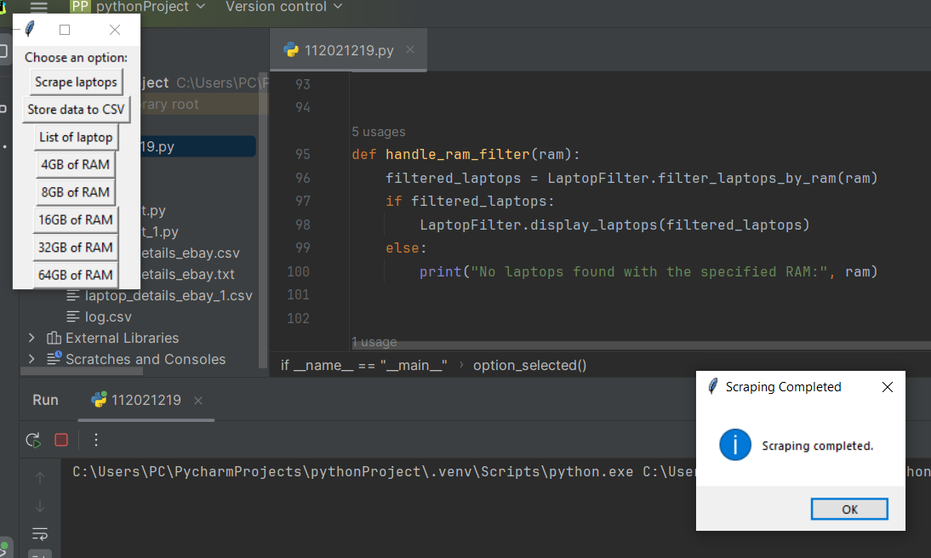

This results show that the program is successfully scrap the data

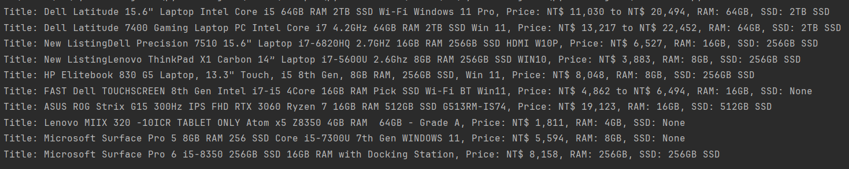

After scrap the data, it will show the list of the laptop’s information in the terminal

**3.2 Result 2**

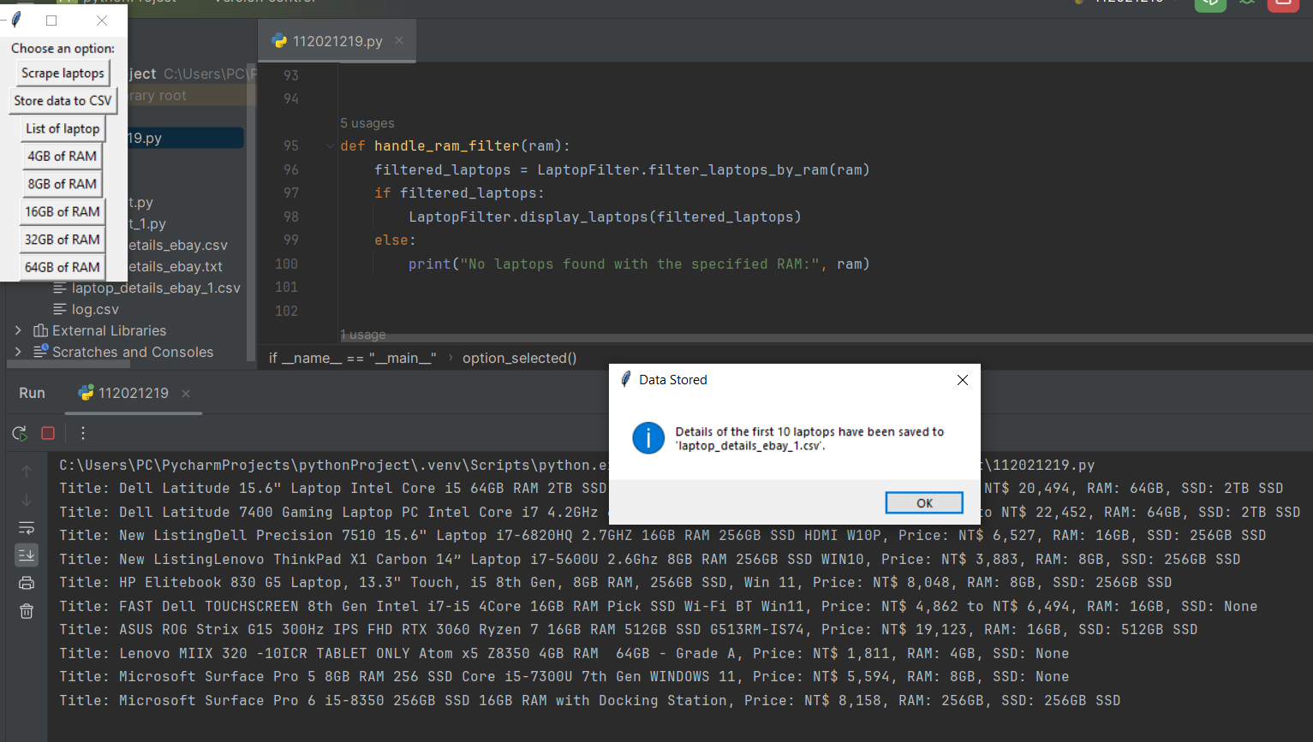

the second button is to store the data into the `laptop_details_ebay_1.csv`

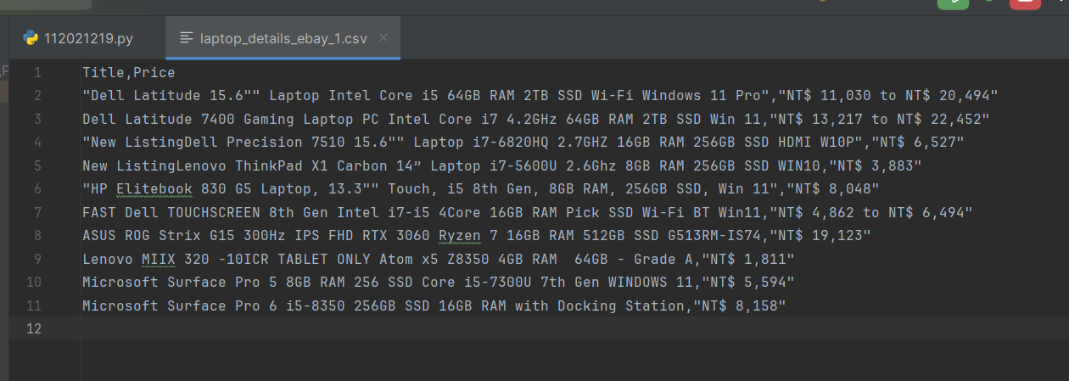

This results show that all the laptop’s information is sucessfully store the data in the csv files

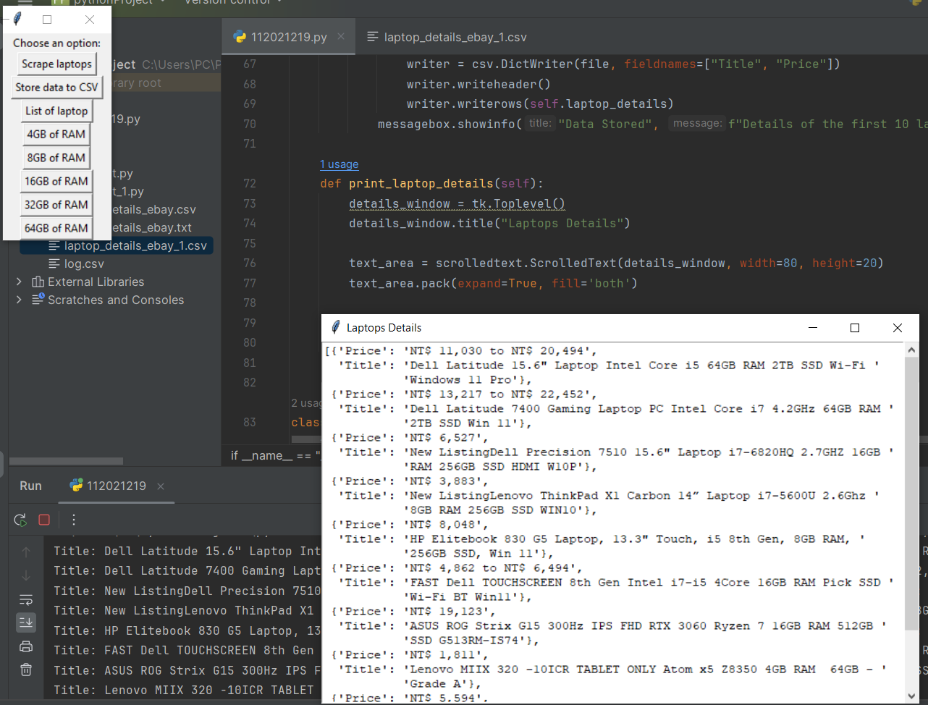

This results show that the program is sucessfully print out the List of laptop’s information

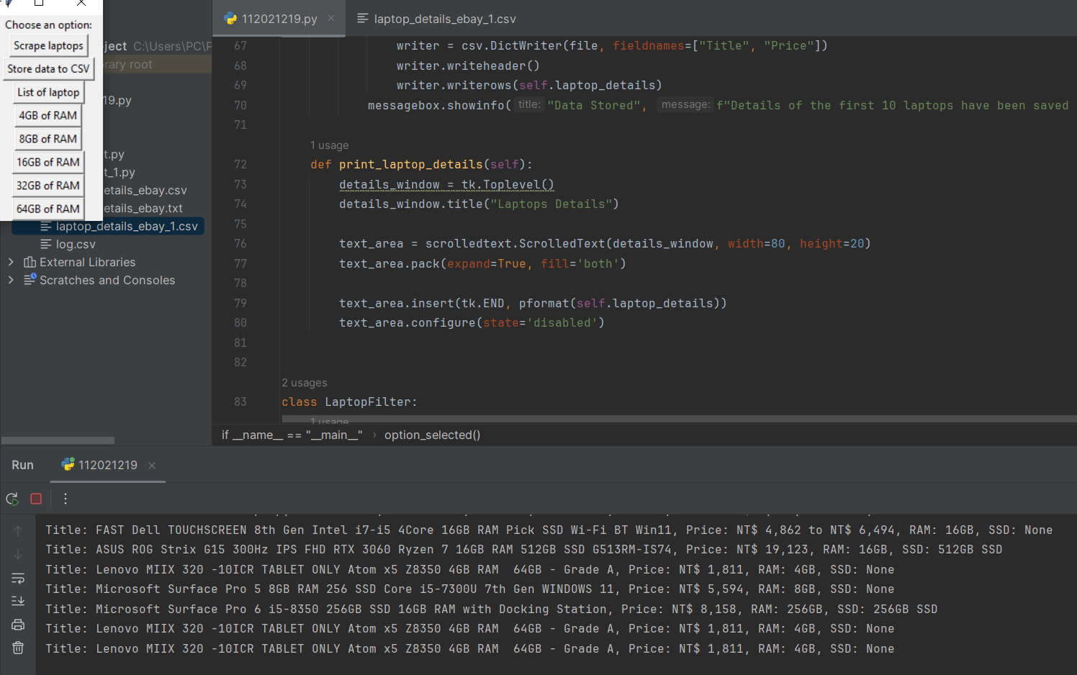

This results show that the program is sucessfully list the laptop with 4GB of RAM

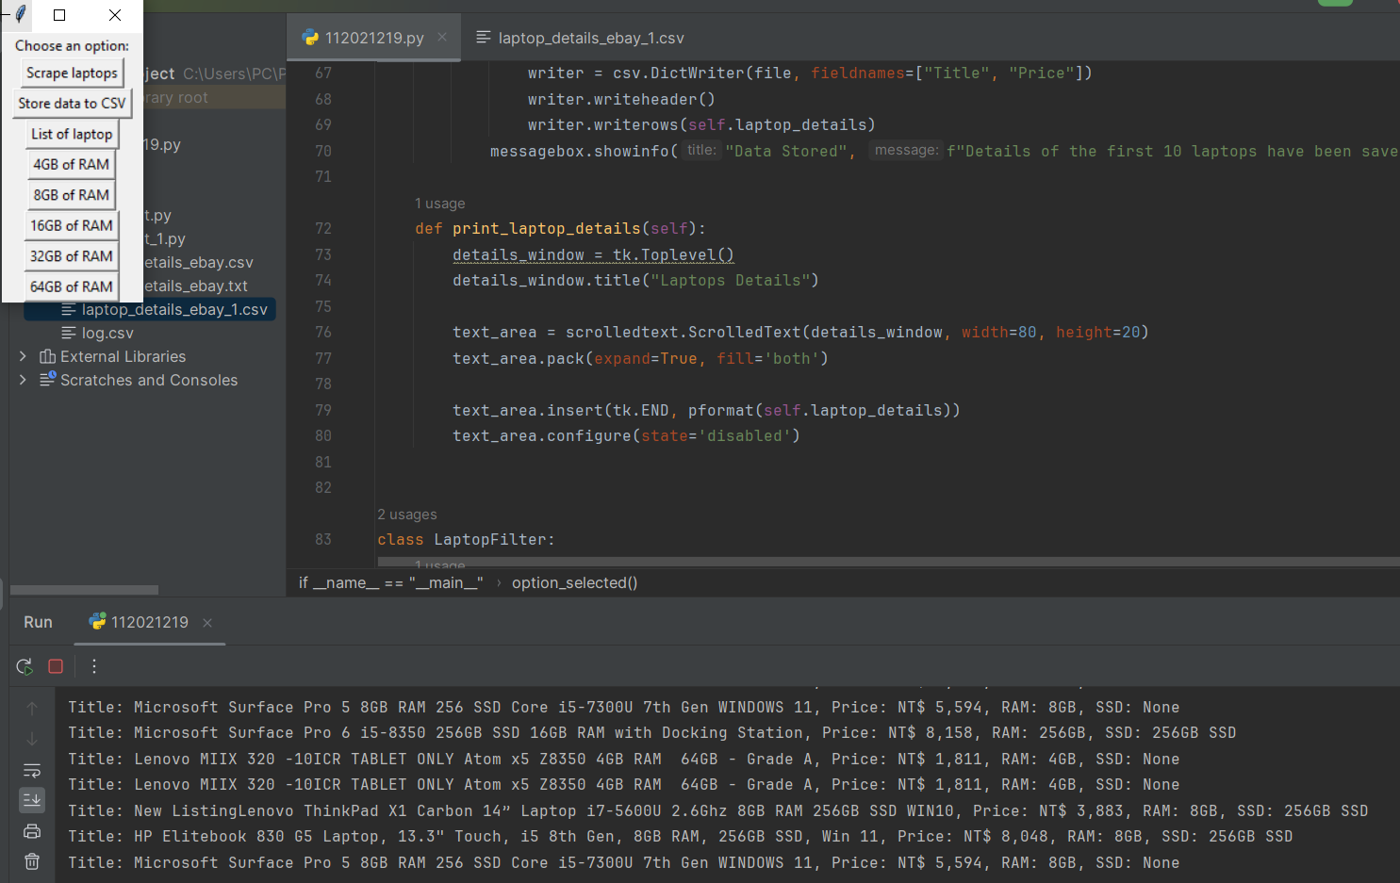

This results show that the program is sucessfully list the laptop with 8GB of RAM

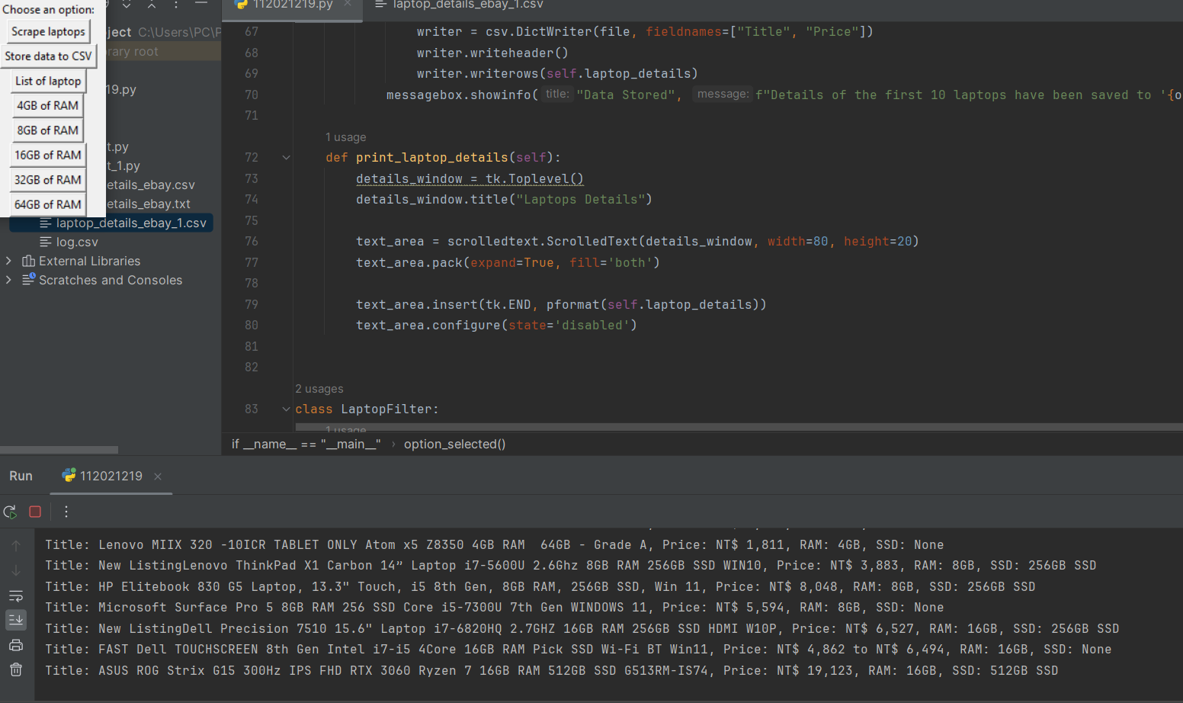

This results show that the program is sucessfully list the laptop with 16GB of RAM

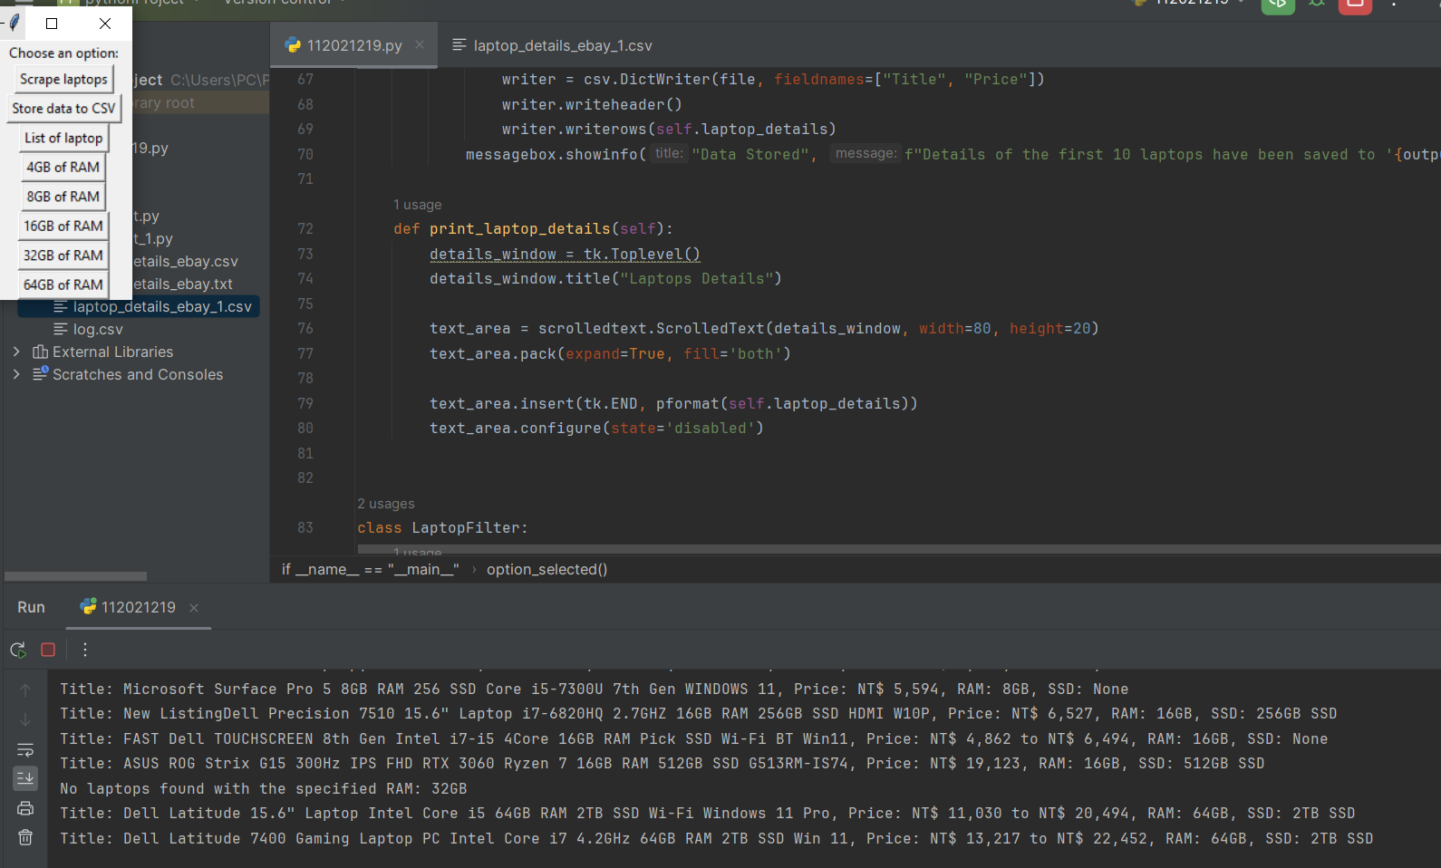

This results show that the program is sucessfully list the laptop with 32GB of RAM



This results show that the program is sucessfully list the laptop with 64GB of RAM

**Chapter 4 Conclusions**

After this program, I have learnt how to work with varieties types of data. How to use the classes, functions, methods. And also I leart about using BeautifulSoup to srap a website’s information. Handle input/output file with csv. And finally use regular expressions to control some variables.